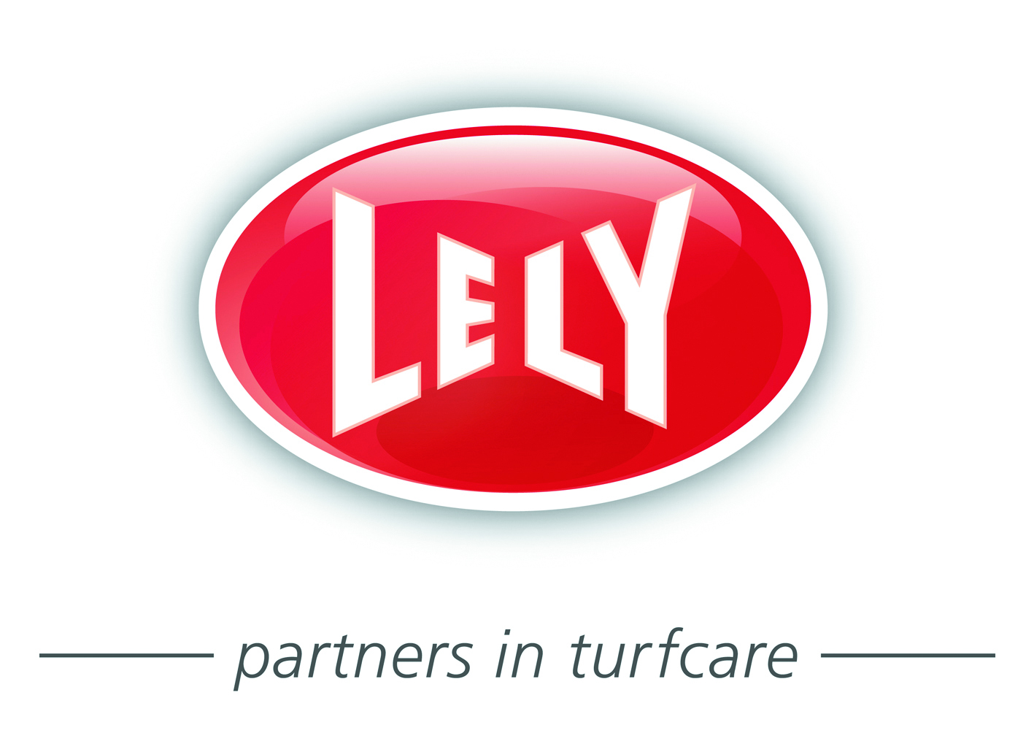

Press release

LELY TO ESTABLISH TURFCARE SERVICE BRANCH
IN SCOTLAND AFTER STRATEGIC REVIEW

Lely UK says it has reached agreement with three of its Toro dealers in Central Scotland to relinquish their contracts at the end of May 2016 to pave the way for Lely to provide its own sales and customer support services in the region.

The dealers are Henderson Grass Machinery, Hamilton Bros and Thistle Groundcare Equipment. They will continue to receive Lely’s full support and backing between now and the end of May for sales activity. All parties will work together to ensure a smooth transition of the Toro business to a new service centre in the region currently being planned by Lely.

Maintaining the excellent customer service provided by these dealers will be a top priority, with ongoing co-operation and support in place for the dealers to meet servicing commitments going forward.

The move follows a review of Lely’s route to market strategy for Toro products.

The review concluded that change was needed if the long-term aims for the Toro brand and business in Central Scotland were to be realised – in particular the desire to enhance the focus on the Toro brand, as well as Lely’s TYM compact tractor offering.

MORE

– 2 –

Lely UK turfcare senior manager David Cole said: “The process leading to this decision was undertaken in collaboration with The Toro Company and has not been undertaken lightly. To be clear, our decision in no way reflects on the performance of the businesses affected. It’s more a case of enhancing our brand positions and channelling resources for growth. Our vision for that growth and future customer support has created a roadmap for where we can take our brands in the next five to 10 years in Scotland.

“We are very grateful to the dealers affected by this decision for their good work in the past and expect to continue to work with them going forward.”

In a joint statement, the directors of the dealers said: “As independent family businesses we are proud to have firmly established the global Toro brand locally in Scotland over the last 15 years. This has been achieved by nurturing our clients, building their trust in the Toro brand and in that of our respective companies. Whilst we are disappointed at Lely’s decision to move the operation in-house, we shall embrace the change and reassure our immensely loyal customers that we will continue to maintain our exemplary standards of service until the cessation of their contracts.”

ENDS

Note to editors: Lely (UK) Limited is the UK mainland distributor of Toro Golf, Fine Turf and Grounds products, TYM Tractors and Otterbine pond and lake aerators. The company is based at 1 Station Road, St Neots PE19 1QH. Call 01480 226800, email turfcare.uk@lely.com or visit www.lelyturfcare.co.uk for further details.

For further press information contact:
David Cole at Lely (UK) Limited
Telephone: 01480 226800
Email: dcole@lely.com

Issued on behalf of Lely (UK) Limited
by oneagency.co, Norwich NR1 1RY

oneagency.co/PR4355/ScotlandDealersrelease/CT/DC/09.11.2015

