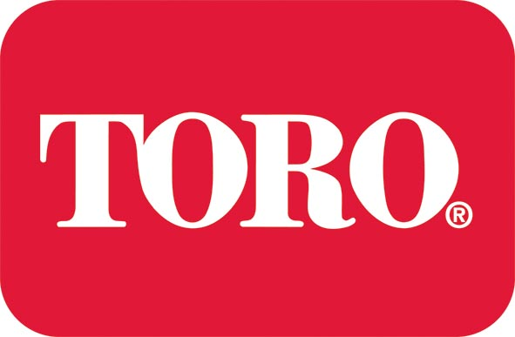

Press release

COURSES MORE CLOSELY TAILORED TO GREENKEEPERS’ NEEDS IN LATEST LELY TRAINING GUIDE

UK Toro distributor Lely has launched its new Turfcare Training Programme for 2016, which sees reviewed course content more closely tailored to customers’ needs.

Accessible via www.lelyliterature.co.uk, the 12-page guide comprises details on courses including the Compact Tractor Driving Award, suitable for both novice and experienced tractor drivers, and the Instructional Technique Course, aimed at those wanting to develop their instructional skills and run in-house operator training courses for groundscare equipment.

Neil Adams, head of training at Lely UK, says: “The new 2016 programme features all of the industry-leading courses Lely is known for; but, following customer feedback, each course has been altered to align perfectly with industry requirements.”

Neil goes on to say that 2015 saw a high uptake in two particular courses, the Turfcare Mechanic Course, aimed at dedicated mechanics working with groundscare machinery, and the Cutting Technology and After-cut Appearance courses, aimed at greenkeepers, landscape contractors and local authorities. “There is a big call in the industry for these two,” notes Neil, who adds that Lely’s Advanced Pesticides Application Course also proved popular.

“Pesticide application has remained a hot topic in the turfcare industry since regulations that implement the Sustainable Use Directive (SUD) came into effect in the UK,” Neil explains.

“Previously, anyone born before 31 December 1964 did not need a specified Certificate of Competence (CoC) to apply professional plant protection products (PPP). As of now, however, everyone requires a CoC to apply pesticides.”

The SUD, mandatory throughout the EU, is designed to further enhance the high level of protection achieved through the entire regulatory system for pesticides.
However, implementation of the SUD heavily relies on the training of all those involved in pesticide application across the industry.

Furthermore, Neil, says the NSTS test will become a requirement for all boom sprayers by 2016 under the requirements of the SUD and be retested every five years until 2020 when the requirement for re-testing reduces to every three years.

ENDS

Notes to editors: Toro turf products are distributed throughout mainland UK by Lely Turfcare, 1 Station Road, St Neots PE19 1QH. Call 01480 226800, email turfcare.uk@lely.com or visit www.lelyturfcare.co.uk / www.toro.com for further details. And in Ireland by Lely Ireland Limited, Kilboggin, Nurney, Co. Kildare. Call 00 353 (0)45 526170 or email turfcaresales.ie@lely.com.

Lely UK is also on Twitter @LelyUKTurfcare and LinkedIn at www.linkedin.com/company/lely-turfcare.

Image caption: Lely UK’s Turfcare Training Guide 2016

Editorial charges: Please email all requests to rosie@oneagency.co

For further press information or alternative images contact:
Rosie Duckworth at oneagency.co
Telephone: 01603 252555

Issued on behalf of Toro Commercial
by oneagency.co, Norwich NR1 1RY

oneagency.co/ToroCommercial/PR4356/TrainingGuide2016Greenkeepers/JD/JG/HJ/NA/04.12.2015

